BSCS 1101: INTRODUCTION TO ENTERPRISEBRESOURCE PLANNING(ERP)

NAME: AKANJUNA MARTIN
REG:NO: 26BSCS0109
COURSE: BSCS
Project: HRM +CRM management system (PHP+ MySQL+XAMPP

TABLE OF CONTEN
- Introduction
- System architecture and integration database
- ERP prototype and implementation
- Screen shot and functionality
- Challenge faced
- Conclusion and recommendation
- AI support and statement
- DDL+Github link

- Introduction.
The purpose of the project was to design and implement a lightened ERP prototype integrating two business modules.
- System architecture.

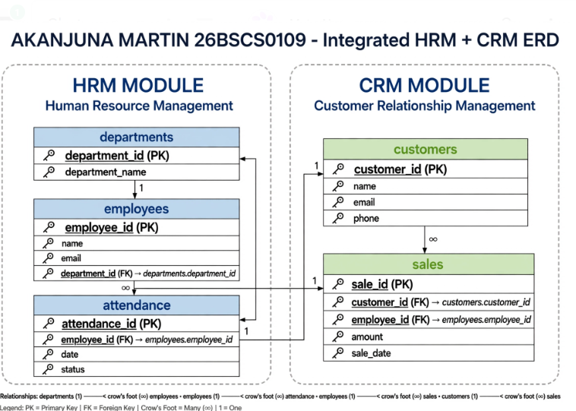

Explanation: The integration point is the sales table which contains both employee ID (from HRM) and customer ID (from CRM). This ensures data flows seamlessly.
- ERP PROTOTYPE IMPLEMENTATION
Language Used: PHP, MySQL, HTML, CSS
Platform: XAMPP localhost (localhost)
Features Implemented: CRUD operations for Employees and Customers, Central Dashboard.
4: SCREENSHOTS & FUNCTIONALITY
Figure 2: Dashboard showing 25 Employees, 120 Customers, 5 Departments
5: CHALLENGES FACED
config.php connection failed due to wrong password - fixed by setting $password and Windows screenshot capturing extra windows - fixed by using Snipping tool
6: CONCLUSION & RECOMMENDATION
In conclusion, this mid-term project successfully achieved its core objective of designing and implementing a functional Enterprise Resource Planning (ERP) prototype that demonstrates the principle of enterprise integration.
Recommendations for Future Enhancement: Security: Implement role-based access control (Admin, HR Manager, Sales Rep) and password hashing. Module Expansion: Add Financials (payroll, invoices) to make it a full ERP suite. Cloud Migration: Deploy from localhost to a cloud platform like Supabase or Render for real-time accessibility. Analytics: Add reporting features such as monthly sales per employee and attendance analytics.

AI SUPPORT STATEMENT & PROMPT AUDIT LOG
I used Meta AI for assistance. Tool Used: Meta AI (WhatsApp)
Prompts Used: “How to fix config.php database connection error in XAMPP?""How to take dashboard screenshot only, not whole screen in Windows? “What is meaning of characters in my ERP database? “Design ERD for HRM + CRM integrated database for my ERP project"

